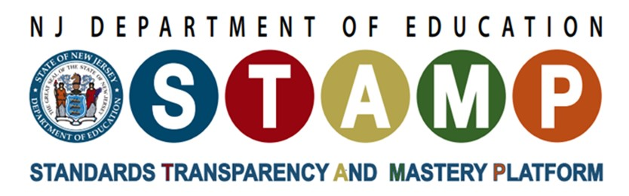

# **Classroom-Based Science Assessment Must-Haves**

## **What Is the Issue?**

Science assessment tasks designed for New Jersey Student Learning Standards for Science (NJSLS-S) can—and should—come in all different forms. To help all students develop proficiency in science, they need feedback from different kinds of assessments including quick checks during the process of learning, conceptual deep-dives and authentic transfer tasks. With so many different types and uses of assessments, it has been tricky to identify what really sets a three-dimensional assessment apart from a traditional assessment. This practice brief describes the must-haves when making student thinking visible.

## **Why Does It Matter to You?**

**Educators:** Assessment is the process of gathering evidence of student learning to inform education-related decisions. The impact of decisions depends on the quality of the evidence gathered, which in turn, depends on the quality of the assessment, and associated practices used to gather it.

**School Leaders:** Classroom-based assessments provide real-time insights into student learning, allowing instructional leaders to monitor the effectiveness of teaching practices, identify areas where students need additional support, and make informed decisions about curriculum adjustments and interventions, ultimately leading to improved student achievement across the school ([Bottoms, G., 2003](https://www.issuelab.org/resources/11627/11627.pdf)).

## **Science Assessment Must-Haves**

* **Be focused on a phenomenon or problem.** To reveal how well students understand and can use the science and engineering practices, disciplinary core ideas, and crosscutting concepts, assessment tasks must focus on [making sense of a phenomenon or addressing a problem](https://issuu.com/achieveinc/docs/phenomena_02142019).
* **Require students to engage in sense-making.** Perhaps the most important shift for NJSLS-S assessments is that they must ask students to actively engage in [sense-making](https://issuu.com/achieveinc/docs/sense-making_02142019__7_) as the central goal of the assessment. This means assessment tasks should emphasize reasoning as the way students show their understanding of science ideas and practices, rather than rote ideas and procedures.
* **Require students to use both science ideas and practices.** From exit tickets to final exams, students must be required to use at least one science and engineering practice and one core idea together as part of their sense-making process. This is the floor, not the ceiling: the more comprehensive the assessment, the higher the bar for what students need to demonstrate. For more information about assessing the three dimensions, see these resources on assessing [practices](https://issuu.com/achieveinc/docs/seps_02142019__8_) and [crosscutting concepts](https://issuu.com/achieveinc/docs/cccs_02142019__2_).
* **Make sense to students.** All assessment tasks need to be [coherent and understandable to the students being asked to respond](https://issuu.com/achieveinc/docs/equity_02142019__3_). This means that tasks use as many words as needed, but no more; provide students with enough information that the full range of students expected to respond to the task can understand what is going on and what is being asked of them; and are scaffolded logically and with purpose from the student perspective, such that students understand how each part of the task builds toward making sense of the phenomenon or problem they are addressing.
* **Support the intended purpose and use.** Tasks have different purposes, and it is important that each task is designed to provide evidence to meet that purpose. For example, lesson exit tickets may focus more on the specific parts of practices, core ideas, and crosscutting concepts that were addressed in the lesson without focusing on the full grade-band expectations, while end-of-course exams may emphasize students’ ability to transfer their grade-appropriate understanding to new contexts and be able to use multiple practices, core ideas, and crosscutting concepts together. It is critical that assessments are designed to support their intended purpose and use—and that [we are transparent about what is being assessed and what isn’t](https://issuu.com/achieveinc/docs/tradeoffs_and_systems_02262019b).

## **Attending to Equity**

* Formative assessment can narrow achievement gaps by generating information that can guide instruction for all students.
* Formative assessments can be designed to be accessible to culturally and linguistically diverse students in ways summative assessments cannot and allow students to respond in a variety of ways (e.g., in their native language or with the support of other students).
* Effective formative assessments can be situated in compelling, everyday-relevant contexts that are more accessible.

## **Tools for Developing Local 3-D Assessments**

* [Short Course: How to Develop Three-Dimensional Formative Assessments for the Science Classroom](http://stemteachingtools.us12.list-manage.com/track/click?u=3de60c5941b2f01e88a3a49cd&id=0179f8c2e0&e=0a67d642e4)
* [Integrating Science Practices into Assessment Tasks](http://stemteachingtools.org/brief/30)
* [Prompts for Integrating Crosscutting Concepts into Assessment and Instruction](http://stemteachingtools.org/brief/41)